STUDENT – COUNCIL ELECTION TALLY SYSTEM

Abstract:
The student-Council Election Tally System is a Java-based program used to record and count votes for student-council candidates. The system allows the user to enter the number of students voting, select candidates, calculate the total votes received by each candidate, and display the election results.
The project demonstrates basic Java programming concepts such as data types, input/output, operators, conditional statements, loops, methods, recursion, and one-dimensional and two-dimensional arrays.

Advantages
- Makes vote counting simple and organized.
- Reduces manual calculation errors.
- Displays the total votes received by each candidate.
- Can handle multiple students and candidates.
- Demonstrates important Java programming concepts.
- Easy to modify for different numbers of candidates.

CODE:

import java.util.Scanner;
public class StudentCouncilElection {
public static void main(String[] args) {
Scanner sc = new Scanner(System.in);
System.out.print("Enter number of candidates: ");
int n = sc.nextInt();
sc.nextLine();
String[] candidates = new String[n];
int[] votes = new int[n];
for (int i = 0; i < n; i++) {
System.out.print("Enter name of candidate " + (i + 1) + ": ");
candidates[i] = sc.nextLine();
}
System.out.print("Enter number of voters: ");
int voters = sc.nextInt();
for (int i = 0; i < voters; i++) {
System.out.println("\nVoter " + (i + 1));
System.out.println("Choose a candidate:");
for (int j = 0; j < n; j++) {
System.out.println((j + 1) + ". " + candidates[j]);
}
System.out.print("Enter candidate number: ");
int choice = sc.nextInt();
if (choice >= 1 && choice <= n) {
votes[choice - 1]++;
System.out.println("Vote recorded successfully.");
} else {
System.out.println("Invalid vote.");
System.out.println("Vote not counted.");
}
}
System.out.println("\n================================");
System.out.println(" STUDENT COUNCIL ELECTION");
System.out.println(" FINAL RESULTS");
System.out.println("================================");
for (int i = 0; i < n; i++) {
System.out.println(candidates[i] + " : " + votes[i] + " votes");
}
int winnerIndex = 0;
for (int i = 1; i < n; i++) {
if (votes[i] > votes[winnerIndex]) {
winnerIndex = i;
}
}
System.out.println("\nWinner: " + candidates[winnerIndex]);
System.out.println("Votes received: " + votes[winnerIndex]);
sc.close();
}
}

OUT PUT:

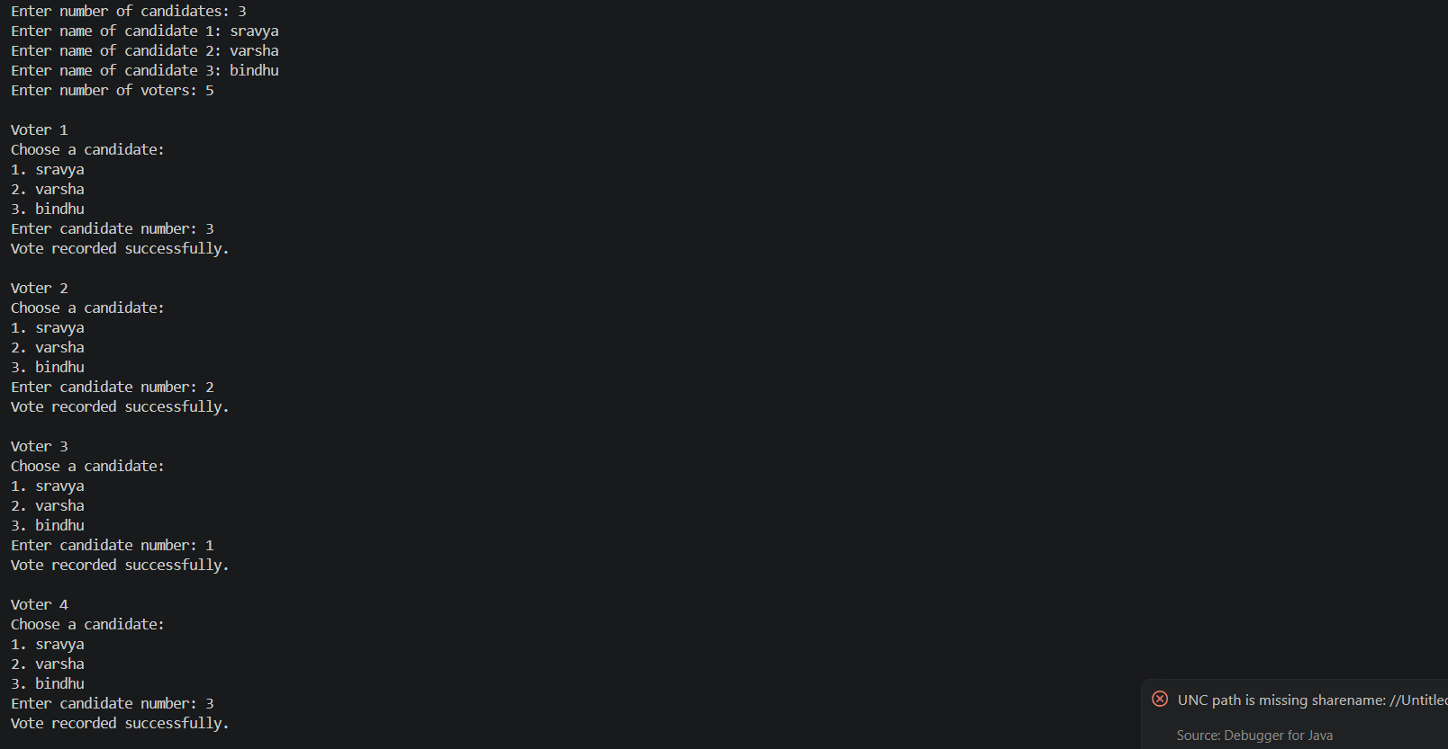

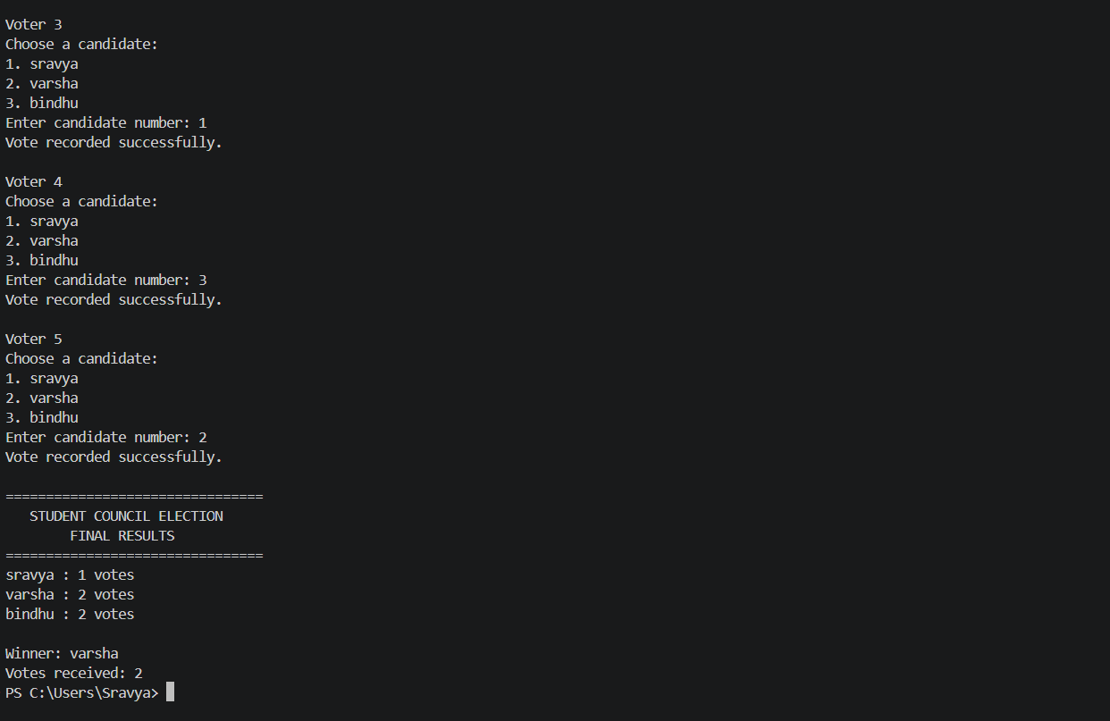

Conclusion
The Student-Council Election Tally System successfully demonstrates how a real-world problem can be converted into a Java program. The project begins with basic programming foundations in CO1, applies selection and iteration in CO2, and extends the program using methods, recursion, and one-dimensional and two-dimensional arrays in CO3. This project provides a practical understanding of how different Java concepts can be combined to create a useful application.

